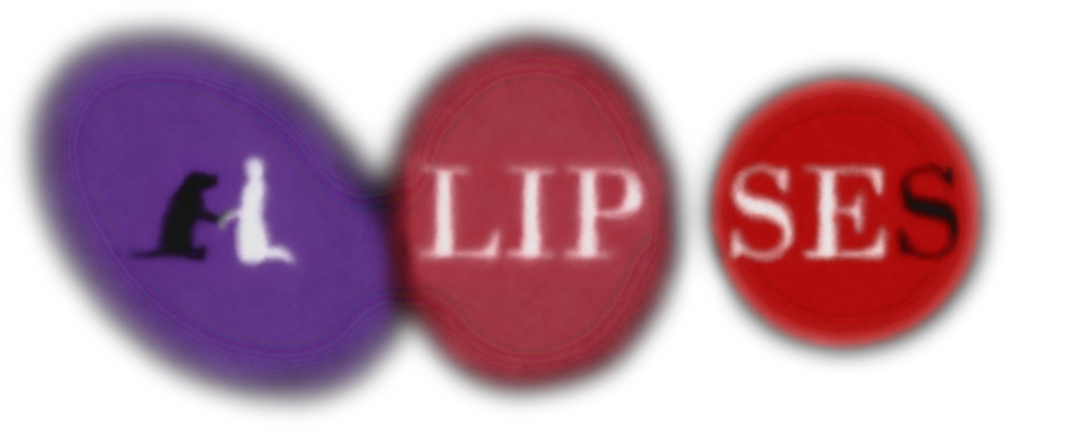

**INFORMATION FOR EDUCATORS**

The mission of ELLIPSES’s 4D program is to introduce young students to the performing arts as the tools for exploration through learning and entertainment. This educational packet is meant to provide your students a basic introduction to the science and themes of this family musical. This will also present theatrical elements used in the production.

We strive for you to use the experience of viewing ELLIPSES with your students as a teaching tool. The educator knows the needs of each student. We encourage you to adapt this packet for activities and discussions.

**Contact David Quang Pham, the Author, at davidquangpham@outlook.com if you need any galactic adjustments or astrophysical assistance.**

**WE CAN’T WAIT TO UNROLL OUR FABRIC OF SPACETIME WITH YOU!**

**THE STAGE BEYOND THE FOURTH DIMENSION**



When you embody the celestial observer as an audience member in the outer space, you play a part. It requires you to believe the actions of the inner space are reality. The stages of the Universe are happening before your very eyes! Let the theatre unfold you and enfold you. Laugh, cry, and applaud with sincerity. The celestial performers on stage are aware of your reactions and reflections. This is an interdimensional relationship that can only spark in the theatre space.

**SYNOPSIS**

ELLIPSES is a musical science fantasy about family, child development, and adulthood. It follows Singularity, their six children, and their quest to undo the Big Bang, after a family member sets it off. When JD strikes down Singularity to run away from home with Gravity (the family dog), their younger siblings are left to fend for themselves in the vastness of the cosmos. The supermassive heart of this coming-of-age story is finding oneself in the nothingness…

**CHARACTER BREAKDOWN**

⬭ Androgyny and Astronomy ⬭

The characters do not have an assigned gender. Any gender can play these roles.

**Character** **Nature Identity**

**SINGULARITY** Super Infinite Black Hole Adult

The relativistically impossible single parent.

Singularity wants to keep the oneness of the Universe.

**GRAVITY** Tidal Force Any

A tidal dog.

Gravity wants to ground and free up the wide-open space.

SPT0615-**JD** Embryonic Galaxy Young Adult

The distant galactic sibling.

JD wants to shed light and be apparent to their lightless legacy.

**CARTWHEEL** Ring Galaxy Teen

The aerobic galactic sibling.

Cartwheel wants to earn their ring.

**WHIRLPOOL** Grand-Design Spiral Galaxy Teen

The anaerobic galactic sibling.

Whirlpool wants to spiral into enlightenment.

**TRIANGULUM** Spiral Galaxy Teen

The jingoistic galactic sibling.

Triangulum wants to be the role model.

**ANDROMEDA** Spiral Galaxy Teen

The scenic galactic sibling.

Andromeda wants to find the pearl in this universal oyster.

**MILKY WAY** Barred Spiral Galaxy Preteen

The angelic galactic sibling. Milky Way wants their voice to be all that it is cracked up to be.

**DRAW A PLANET**

**DRAW A STAR**

**DRAW A GALAXY**

**WHAT IS A GALAXY?**

Galaxies are concentrations of stars, gas, dust, and dark matter all held together by gravity. Many galaxies are spiral galaxies, but there are also elliptical and irregular galaxies. Most large galaxies have a supermassive black hole at their centers.

Small Galaxies serve as building blocks for larger galaxies or draw near to their hulking neighbors. Scientists have now found nearly 60 small Galaxies orbiting the Milky Way, and think there may be scores more still undetected

**ACTIVITIES**

1. Divide the class into the elliptical, spiral, and irregular Galaxies. Have them research their categories.

2. Ask each group to think of words that rhyme with “Galaxy.”

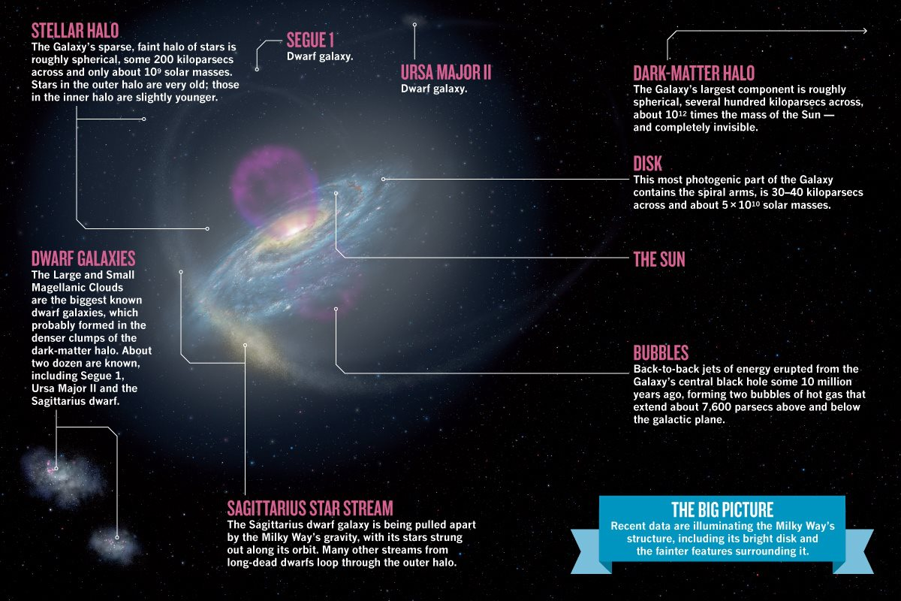

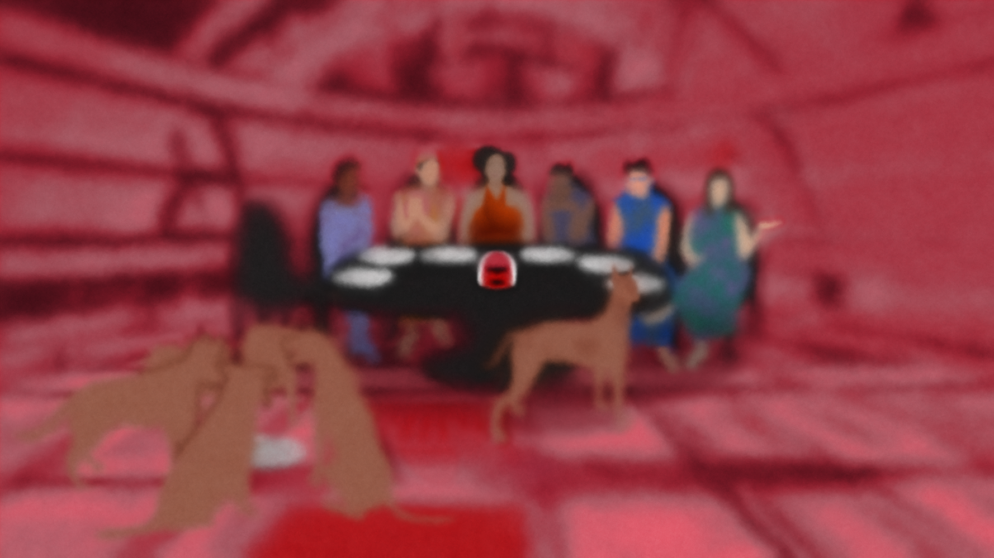**THE GALAXY PORTRAIT**

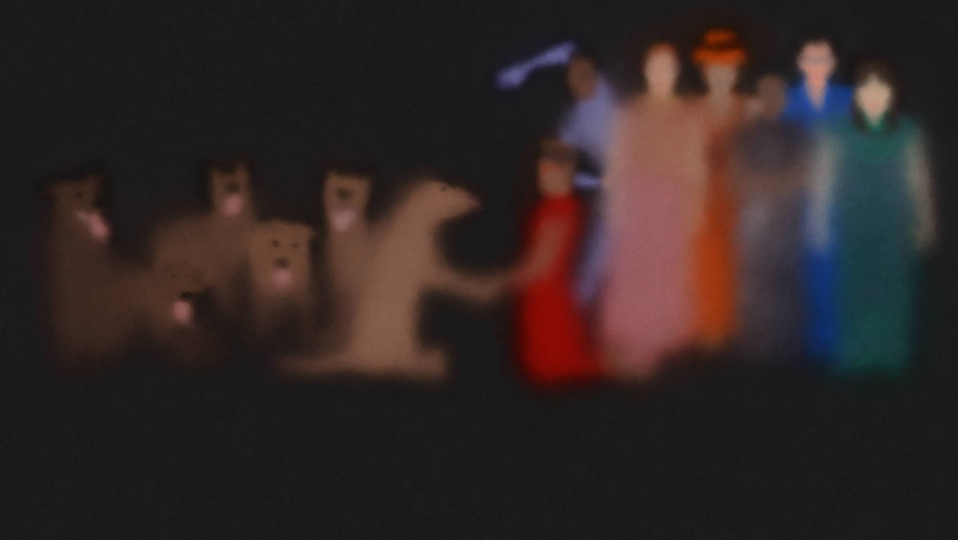

**NAME THE GALAXIES**

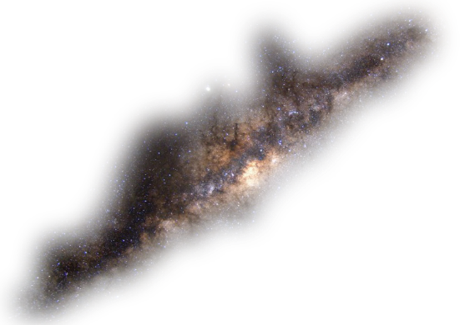 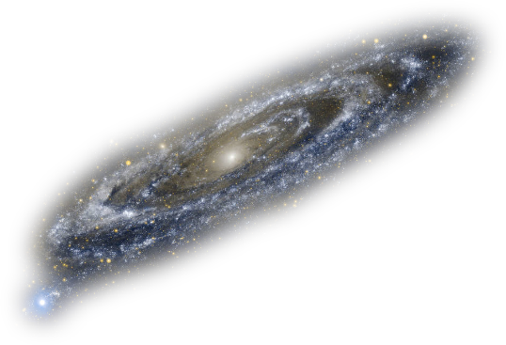

____________________ ____________________

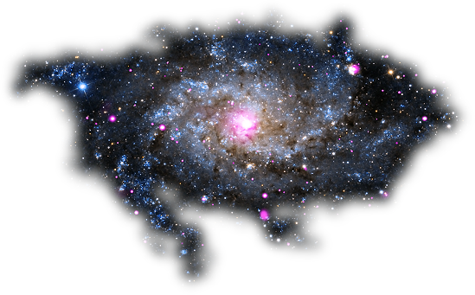 

____________________ ____________________

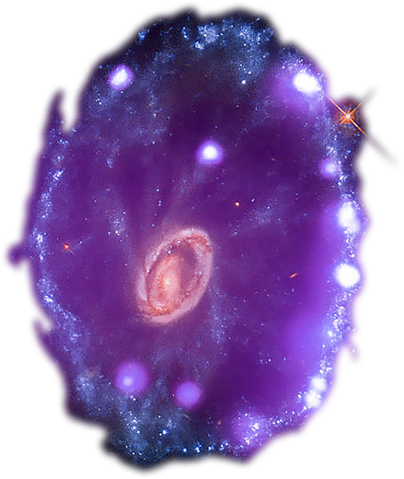 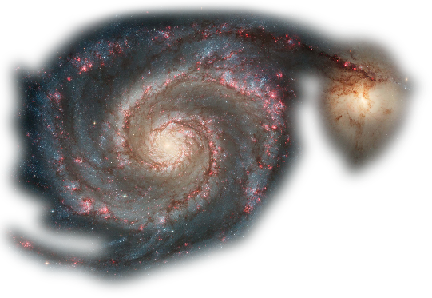

____________________ ____________________

**ASK EACH STUDENT’S FAVORITE GALAXY**

**MILKY WAY**

There may be trillions of Galaxies in the Universe, but that does not mean the Milky Way is not special. In fact, large Galaxies like our own are often the exception, not the norm. Our Universe is populated by a plethora of small and faint Galaxies.

In ELLIPSES, Milky Way is the baby sibling and one of Singularity’s six kids. They are going through warps, waves, and wrinkles (galactic puberty). Their major big production number near the end of the first act is “Warp, Waves, and Wrinkles”: <https://www.ellipsesplay.com/music/12-warps_waves_and_wrinkles>

**ACTIVITIES**

1. Discuss how the Milky Way came to be.

2. Ask each student to draw what they think the Milky Way looks like.

3. Listen to the song, “Warps, Waves, and Wrinkles.” Name the arms of the Milky Way. Ask which arm we live on.

4. Discuss the merging of Andromeda and Milky Way in a few billion years. Can your class figure out what a red giant is in the personification of a human anatomy?

5. Discuss the journey that Milky Way is following as it relates to child development from childhood to adolescence.

6. Ask each student to think of a Milky Way in their lives, whether it is their younger sibling or friend.

**POST-SHOW QUESTIONS**

1. What is the name of the home that the Galaxy family live in?

Answer: The Ellipse

2. How old is Gravity, the tidal dog?

Answer: Infinite dog years.

3. Who is the oldest child? Who is the youngest child?

Answer: HD. Milky Way.

4. Who or what caused the Big Bang?

Answer: Gravity or HD caused the Big Bang.

5. After the Big Bang, which Galaxies split up and how are they paired? Which pair was supposed to babysit Milky Way?

Answer: Triangulum and Andromeda. Cartwheel and Whirlpool. Cartwheel and Whirlpool are supposed to babysit Milky Way.

6. What does dilation mean?

Answer: Dilation means “to expand.”

7. What shape is an ellipse or are ellipses?

Answer: Oval shape.

8. What do Gravity and JD play fetch with?

Answer: Stars

9. What does it mean to “parallax” in the context of the song?

Answer: Parallax means to “tilt your head and relax.”

10. Why do Gravity and JD split up?

Answer: JD is returning the Universe to the way things were. Gravity is upset. Gravity likes the wide-open space.

**“WE, SCIENTISTS, HAVE DISCOVERED…”**

**Here is what I learnt from the Galaxy family in ELLIPSES.**

**COLOR THE ELLIPSE**